COIT12202 – Network Security Concepts
Term 2, 2025

Assessment 3 - Report

Student Name: Janet Muthiora
Student ID: 12287751
Lecturer / Tutor: Zhenglin Wang
Unit Coordinator: Zhenglin Wang

Contents
AMC Network Security Design and Strategy 3
Executive Summary 3
Potential Attacks 3
Phishing Attack 3
Distributed Denial-Of-Service 4
Proposed Network Security Technologies 5
Virtual Private Network 5
Next Generation Firewall 5
Security Information and Event Management 6
Network Security Devices 6
Firewall 6
Access Point 7
Role-Based Access Control (RBAC) 7
Authentication Techniques 8
Multi-Factor Authentication 8
Public Key Infrastructure 9
Reflection 9
References 10

AMC Network Security Design and Strategy

Executive Summary
This is a comprehensive cybersecurity and network design strategy for Aussie Mining Corporation (AMC) that is planning to establish a new coal mining site in the west-north region of QLD approximately 100 kilometres West of Mount Isa city. The proposed design is a hybrid architecture combining both on premise and cloud-based systems. Local servers within the office building will be used to manage CCTV data storage and machine control systems while cloud servers will host business applications and data storage. A dedicated fibre optic connection from Mount Isa City is to be implemented. This ensures reliable high-speed communication. For remote access VPN tunnels are suggested with network segmentation to protect internal and external communications. Additionally mesh wireless system supporting IOT-based operations has been included in the design and for 24/7 operation a back-up has been included in the design. The purpose of this report is to design a secure, scalable and efficient hybrid network security infrastructure that support the company’s operational, technical, administrative and security needs. The main problem that needs to be addressed is developing a robust and secure network system that will accommodate heavy duty mining operations, remote data management and administrative communication while still maintaining integrity availability and confidentiality. Key issues are the integration of on premise and cloud infrastructure, data security and access control mechanisms, protection of public and private IP addresses for internal and external communication and reliable connectivity between the mining site and Mount Isa City.

Potential Attacks

Phishing Attack
A phishing attack is a type of social engineering method used by attackers to deceive recipients often using email into diverging credentials and information by clicking on malicious links. Phishing remains one of the highest global threats leveraging exploits and social engineering to steal money, gain access to sensitive data or install malware into the victim's device. Spear phishing is a targeted form of phishing that targets specific individuals within an organisation. The attackers’ goal is manipulating their unsuspecting victims into diverging sensitive information, transferring funds or downloading dangerous malware (Cisco n.d.).

How it would occur
An attacker with access to the corporation’s emails crafts a convincing email that appears to come from the AMC IT department or cloud provider that instructs the employee to verify credentials or login to a cloud portal. This would be the reconnaissance attack.
The email will contain a spoofed login page that may mimic AMC page, and the victim will enter their username and password. This would be their gathering information and credentials stage.
The attacker monitoring the page hijacks the credentials and uses them to access the internal systems or cloud and once in the system they can potentially use it to escalate privileges.

Distributed Denial-Of-Service
A distributed denial-of-service is an attack where the attacker floods target system with excessive traffic to overload the system and exhaust the resources making the system unusable or unavailable to legitimate users. Attackers may use volumetric floods, protocol attacks or application layer floods (Cisco n.d.).

How it would occur
First the attacker conducts a reconnaissance where the attacker identifies AMC’s public IP address.
Using compromised machines, the attacker sends excessive traffic such as SYN floods, ICMP pings or UDP floods toa specific target server or network.
The network infrastructure becomes overwhelmed, it degrades or stops legitimate access from remote users, internal systems or cloud services.
This failure leads to loss of remote telemetry for IOT devices, inability to access the cloud resources or use this disruption as an evasion tactic for other intrusions.

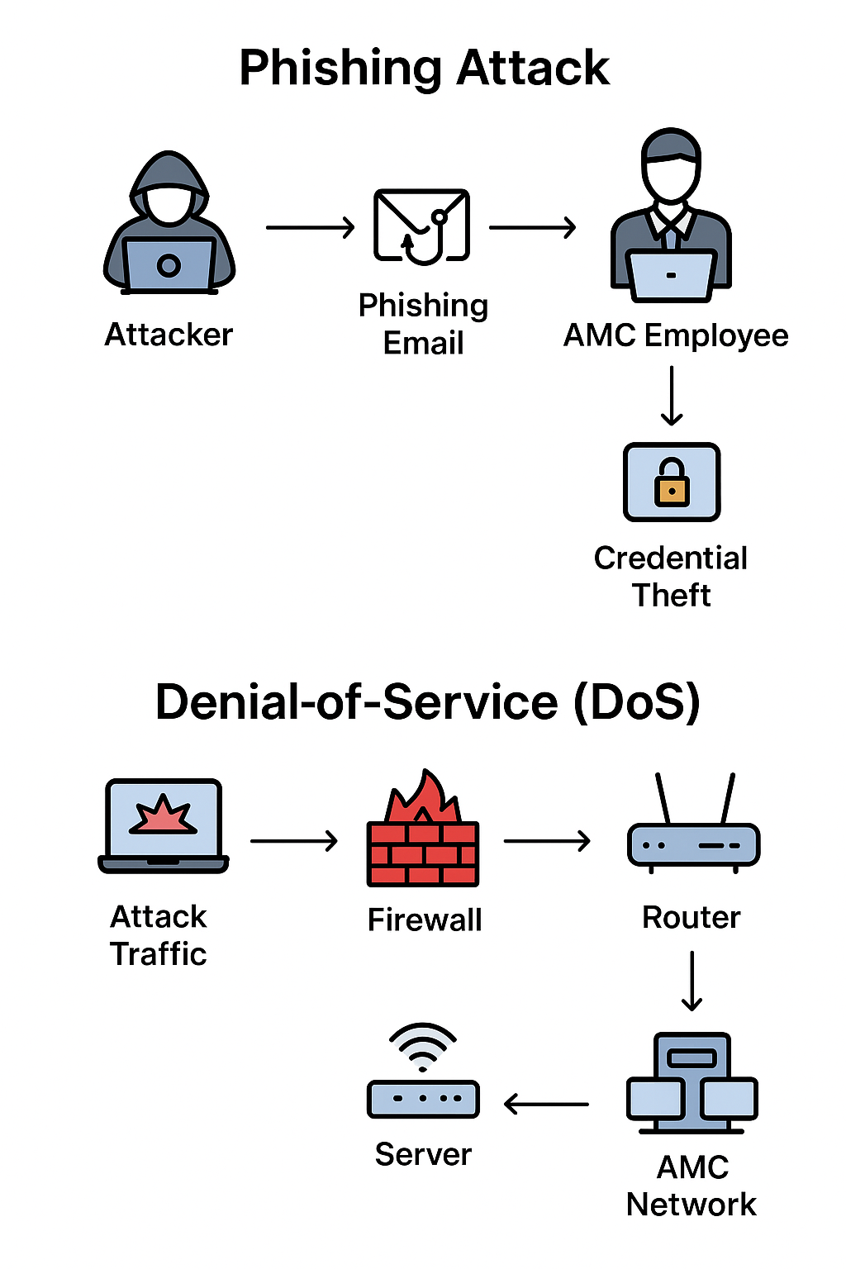Source : Chatgpt

Proposed Network Security Technologies

Virtual Private Network
A virtual private network creates a secure and encrypted communication channel over the public networks such as the Internet (Cisco n.d. -c). This technology ensures confidentiality and integrity of data transmitted between AMC mining sites, the office buildings and cloud infrastructure. It strengthens remote connectivity and protects against man in the middle attacks. This is a technology that would be applied on layer 3 on the OS I model that is the network layer.
This technology enhances security through the following ways
- Encryption- VPNs use encryption algorithms to secure the data transiting through the network preventing eavesdropping or interception.
- Authentication- multi factor authentication ensures only authorised staff access internal systems remotely.
- Data integrity-can be achieved through hashing mechanisms which detect any unauthorised changes during transmission.

Next Generation Firewall
A Next Generation Firewall is a network security device that combines both traditional functions and advanced threat prevention techniques such as integrated intrusion prevention and cloud-delivered threat intelligence (Cisco n.d. -d). This technology will provide a multi layered defense against external threats and internal risks.
This technology enhances security through the following ways
- Traffic filtering – The firewall inspects all traffic flowing this network based on IP, ports and application types. It blocks malicious traffic and unauthorized access to services.
- Intrusion prevention- It detects and blocks malware, exploits and suspicious patterns real-time using signature based or anomaly-based detection.

Security Information and Event Management
This is a software solution that collects, analyses and correlates logs and event data , threat intelligence and security alerts and responds in real time (Cisco n.d. -e). For AMC a SIEM solution could continuously monitor network events ensuring early detection of cyber incidents and alert administrators. This enhances visibility, detection and threat response capabilities.
This technology enhances security through the following ways
- Centralized continuous monitoring – this system collects data from multiple sources such as firewalls, servers, IOT sensors and access points and provides a single dashboard for network administrators and security teams to monitor activities.
- Detection and correlation – the system analyses patterns of behaviour and identify anomalies, threats or coordinated attacks in real time.
- Incidence response – through automated alerts and responses, the security team can provide rapid action to isolated events affecting the system.

Network Security Devices

Firewall
A firewall acts as the first line of defence against unauthorised access by filtering traffic, monitoring and controlling incoming and outgoing data according to predefined security rules. The two main types of firewalls that AMC should deploy are on-premises firewall and cloud-based firewall.
On-premises firewall
Hardware based firewall should be deployed at the main Network gateway whose function will be:
- Filter incoming and outgoing traffic between the internal LAN and external Internet
- Analyse and block malicious traffic such as DDoS, DoS or malware.
- Reinforcement for the virtual LAN segmentation separating administrative, IoT and CCTV systems.
- Filter unwanted traffic early which improves the bandwidth for legitimate users.

Cloud-based firewall
Using cloud-based infrastructure such as Microsoft Azure to host business application, store files and remote access services, as a cloud native firewall will be suitable for centralised protection of all virtual networks. The firewalls functions will be:
- Protect applications from threats such as SQL Injection, cross site scripting and malware.
- Traffic filtering during communication between virtual private network connections and cloud services.
- Logging and monitoring via the Azure monitor and Sentinel for real time alerts.
The figure below is a shows resources created for the Azure lab that involves creating a firewall with inbound and outbound rules. The firewall route tables have the IP addresses ranging from 0.0.0.0/0 to 10.0.1.4 as the private IP assigned. The DNS server IP to Bing.com was allowed in the configuration and can be confirmed from the test that access is allowed however with Microsoft access is denied.
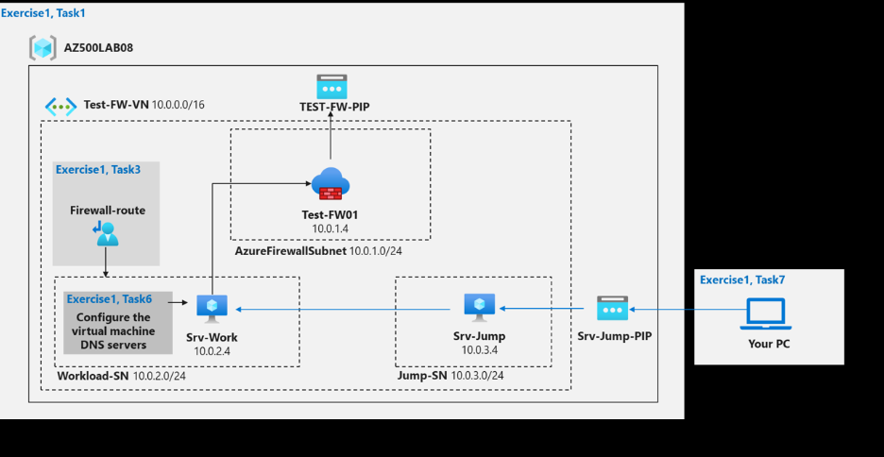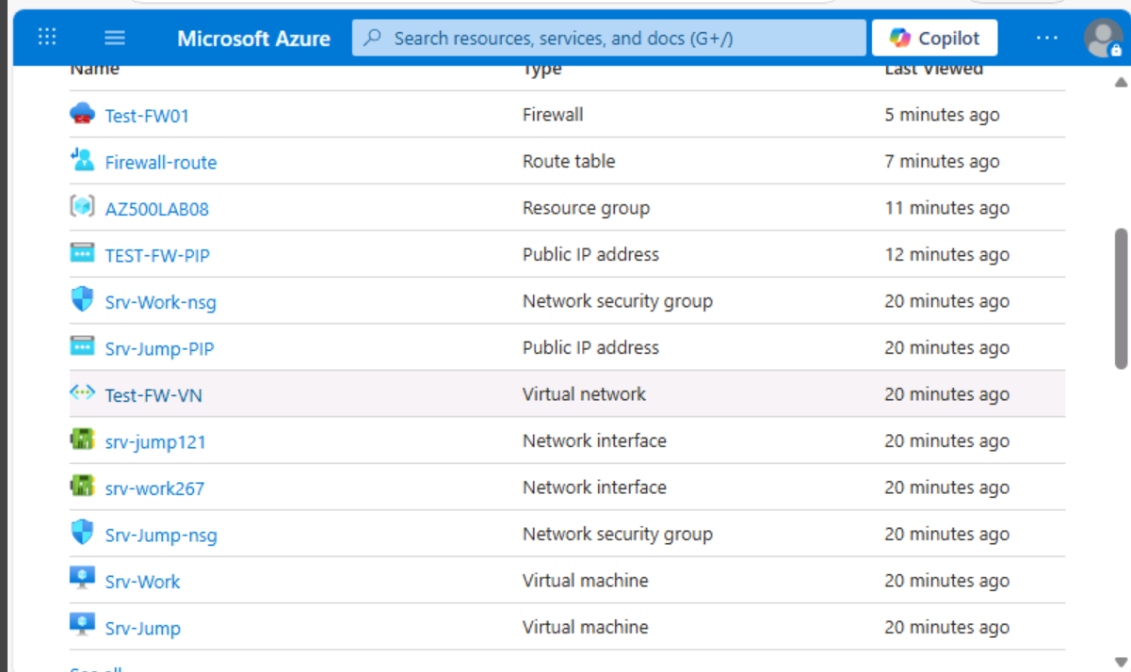
Figure 1 Figure 2
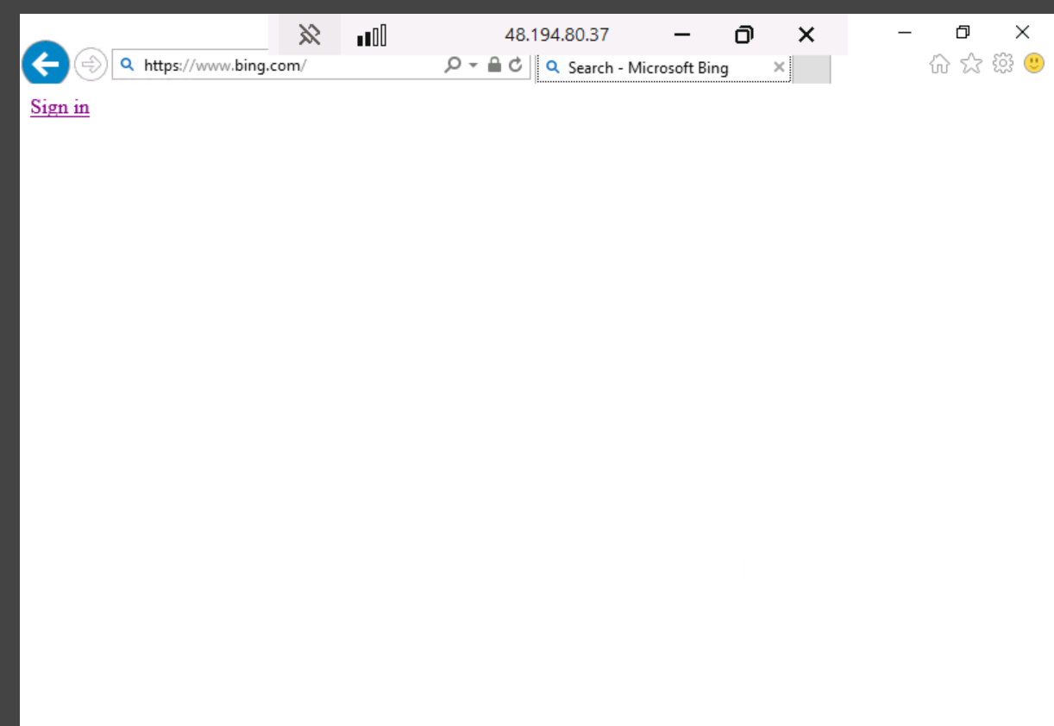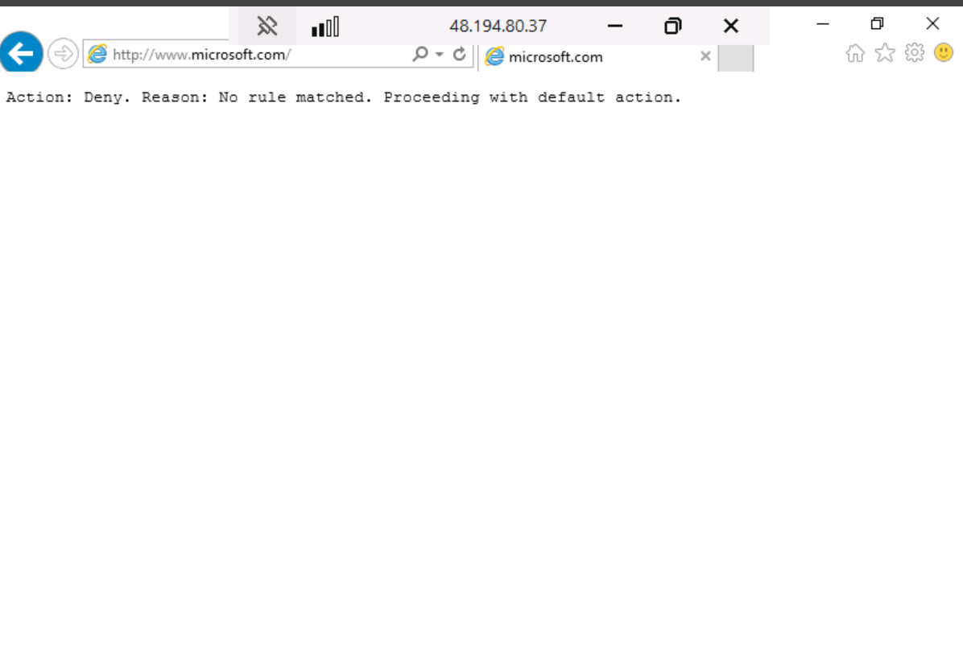
Figure 3 Figure 4

Access Point
An access point is a networking device that provides a wireless connection for wireless devices and IoT based sensors to the wired local area network using wi-fi technology. The Access point functions will be:
- Access points support advanced encryption and authentication protocols.
- Support segregation and segmentation of wireless networks into secure zones.

Role-Based Access Control (RBAC)
This is a security management model that restricts the systems access based on individual roles instead of granting the user direct permissions, the users inherit through role memberships. In AMC, RBAC can be implemented through the cloud platform to regulate access to resources such as servers, virtual machines, data storage and applications.
Possible implementation
- Define the roles: Create roles based on departments and job functions.
- The Executive: Granted full access to the business analytics, finance reports and IoT dashboards.
- The Engineers – Granted full access to the IoT , performance dashboards, and cloud storage.
- The H/R department – Granted access to employee records
- The Finance department – Granted access to the Employee records and Finance databases.
- Assign roles to the users or groups: The administrator assigns users to groups mapped by roles, and this will automatically allocate their permissions.
- Apply role policies to resources
- Monitor and audit
Advantages
- Implements the principle of least privilege which enhances security by ensuring employees only access information and systems necessary for example engineers may only access IoT dashboards. This reduces the risk of insider threats or data breaches (Microsoft n.d. -a).
- Access management is simplified for example when a new employee joins the organization they can be assigned to an existing role without the need to manually configure multiple permissions.
- For compliance and auditability, it is easy to acquire information on who has access to what and the Azure monitor tracks all role assignments and access attempts.

Disadvantages
- Initial setup is complex and requires careful planning of permissions to avoid overlapping or excessive privileges.
- A maintenance overhead is predicted when the organisation scales up which can be time consuming if not managed with automated tools
The figures below demonstrate the creation of a user group, adding a senior administrator and configuring the password using powershell. A junior administrator role is created, and members are created and all are added to the user group.

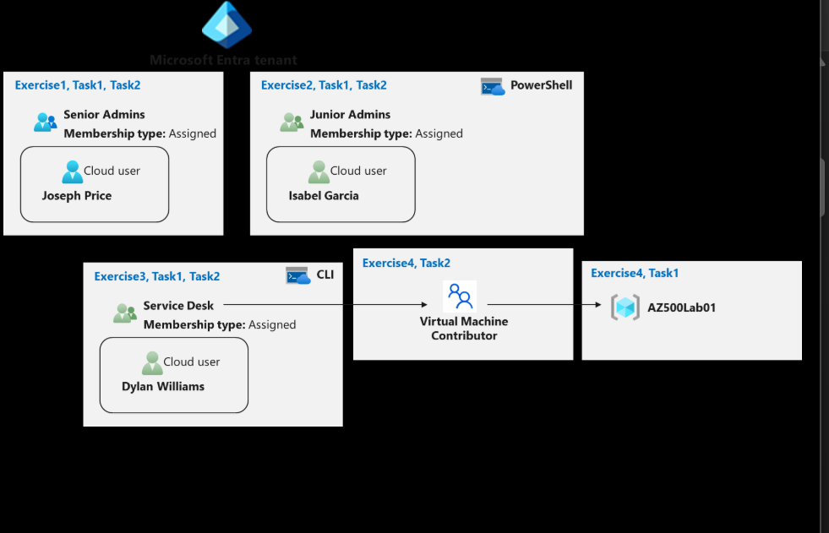 Figure 4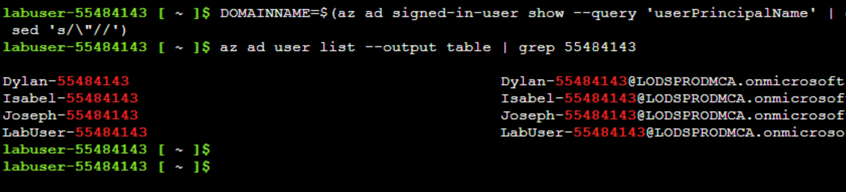 Figure 5
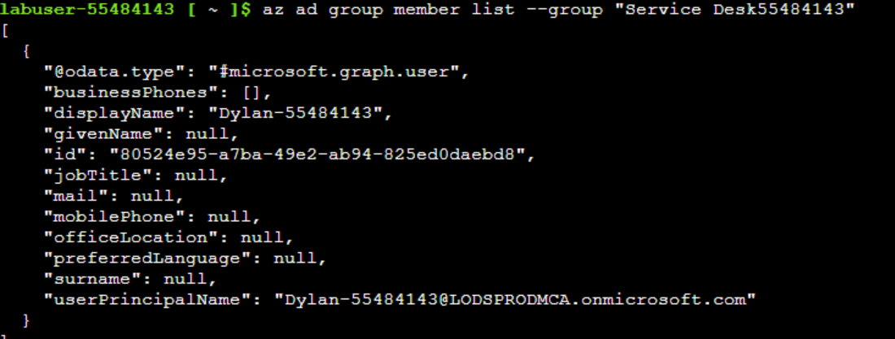 Figure 6
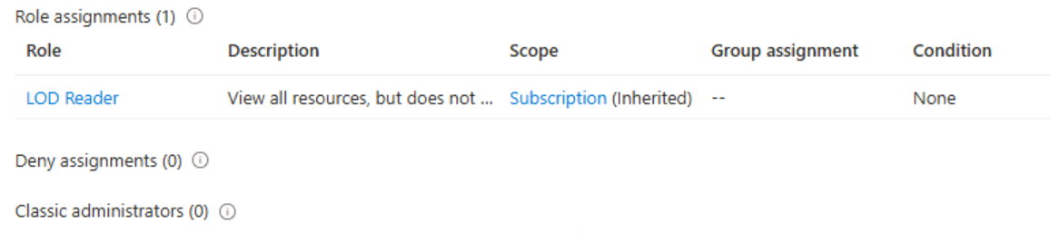 Figure 7

Authentication Techniques

Multi-Factor Authentication
This is a layered mechanism that requires the user to verify identity using two or more verification factors to gain access to an information system. It combines multiple categories such as pins, biometrics or hardware token. MFA can easily integrate with VPN, administrative systems, emails, sharing documents and on the cloud, environment can be used on the Azure Active Directory.
Advantages
- Reduces the risk of unauthorised access even when passwords are compromised
- Easy cloud integration which aligns with the organisation’s hybrid network
- Conditional access is enforced therefore limiting risk of data breaches.
- Promotes security awareness for employees
Disadvantages
- Dependency on devices if the user loses the phone or token they may be temporary locked out.
- Cost of implementation and maintenance of especially hardware tokens may be expensive
Justification
MFA provides an essential layer of security against password attacks and phishing attempts. Integrating MFA with cloud Active Directory offers conditional access to remote users whereby they must verify their identity via a second factor therefore limiting risk of unauthorised access.

Public Key Infrastructure
This is an encryption and authentication framework that involves the use of a public and private keys and digital certificates to verify identity of users. The public key can be embedded in the digital certificate and is used to encrypt data while the private key (only known to the owner) decrypts the data. The digital certificate is issued to each user or device by a trusted Certificate Authority (IBM n.d.). In AMC network structure the PKI system can be used in the CCTV control systems, IoT device validation and secure email communication.

Advantages
- Upholds confidentiality and integrity of data shared within the organisation.
- Strong encryption protects data in transit.
- Suitable for this large-scale network with many users and devices.
- Non-repudiation since digital signatures ensures the sender of the message cannot deny their identity.

Disadvantages
- Single point of failure in the case of a breach and exposure of the public/private key.
- High initial and ongoing costs for implementing and maintain the PKI systems.
- Compromised certificate authorities issuing fraudulent certificates may undermine the trust model of PKI.

Reflection
Completing this case study assignment was a highly informative process that has allowed me to apply theoretical knowledge of network security. I began by studying the lecture materials on the topics related to the case study. Using the Azure labs, deployed to hands on cloud practicals on Azure Firewall and RBAC.
Through this assignment, my understanding of how to secure firewalls and access points has been enhanced as well as the importance of RBAC in managing privileges and principles of least privilege.
Another key outcome is the analysis of the authentication techniques MFA and PKI, suitable for the organisation. A discussion on the advantages and disadvantages of the two techniques enhanced my understanding on the suitability of either technique for this organisation.
My previous experience studying networking fundamentals and cloud computing helped me understand the configuration steps easily and this allowed me to approach the assignment in a structured manner.
Overall, a comprehensive understanding of real-world network security design will be valuable for future projects and are an essential skill for my future career in IT.

References
Cisco (n.d.-a), What is phishing? Cisco, viewed on 08 October 2025,
https://www.cisco.com/site/us/en/learn/topics/security/what-is-phishing.html
Cisco (n.d.-b) What Is a DDoS Attack? Cisco, viewed on 08 October 2025, https://www.cisco.com/site/us/en/learn/topics/security/what-is-a-ddos-attack.html
Cisco (n.d.-c) Virtual Private Networks (VPNs): Overview and Benefits, Cisco, viewed on 08 October 2025,
https://www.cisco.com/c/en/us/products/security/vpn-endpoint/index.html
Cisco (n.d.-d) , Next-Generation Firewall (NGFW) and Intrusion Prevention System (IPS), Cisco, viewed on 08 October 2025,
https://www.cisco.com/c/en/us/products/security/firewalls/what-is-a-next-generation-firewall.html
Cisco (n.d.-e), What Is SIEM? - Security Information and Event Management, Cisco, viewed on 08 October 2025,
https://www.cisco.com/site/us/en/learn/topics/security/what-is-siem.html
IBM (n.d.), What is Public Key Infrastructure (PKI)?, Viewed on 12 October 2025, https://www.ibm.com/think/topics/public-key-infrastructure
Microsoft (n.d.-a) , What is role-based access control (RBAC)?, Microsoft Learn, viewed on 10 October 2025 ,
https://learn.microsoft.com/en-us/azure/role-based-access-control/overview

